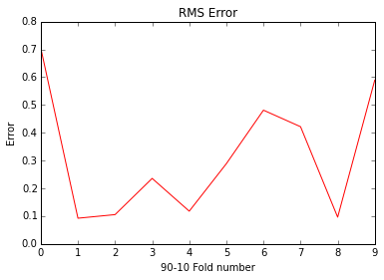

Prediction for unobserved

user: 0 item : 2 rating : 3

user: 0 item : 4 rating : 2

user: 0 item : 5 rating : 2

user: 1 item : 2 rating : 2

user: 1 item : 3 rating : 2

user: 1 item : 7 rating : 2

user: 2 item : 1 rating : 4

user: 2 item : 5 rating : 2

user: 2 item : 6 rating : 2

user: 3 item : 0 rating : 2

user: 3 item : 2 rating : 2

user: 3 item : 3 rating : 2

user: 3 item : 6 rating : 3

user: 4 item : 3 rating : 3

user: 4 item : 4 rating : 2

user: 4 item : 7 rating : 3

user: 5 item : 1 rating : 3

user: 5 item : 2 rating : 2

user: 5 item : 5 rating : 2

user: 6 item : 5 rating : 3

user: 6 item : 6 rating : 2

user: 7 item : 2 rating : 1

user: 7 item : 3 rating : 1

user: 7 item : 7 rating : 3

user: 8 item : 0 rating : 2

user: 8 item : 1 rating : 4

user: 8 item : 5 rating : 2

user: 8 item : 7 rating : 3

user: 9 item : 3 rating : 1

user: 9 item : 4 rating : 3

user: 9 item : 5 rating : 2

user: 10 item : 0 rating : 2

user: 10 item : 1 rating : 4

user: 10 item : 4 rating : 2

user: 10 item : 6 rating : 4

user: 11 item : 2 rating : 2

user: 11 item : 4 rating : 2

user: 12 item : 0 rating : 1

user: 12 item : 1 rating : 5

user: 12 item : 3 rating : 2

user: 12 item : 5 rating : 3

user: 13 item : 0 rating : 3

user: 13 item : 5 rating : 2

user: 14 item : 0 rating : 3

user: 14 item : 2 rating : 1

user: 14 item : 3 rating : 2

user: 14 item : 6 rating : 1

user: 15 item : 0 rating : 2

user: 15 item : 5 rating : 3

user: 16 item : 4 rating : 4

user: 16 item : 6 rating : 3

user: 17 item : 1 rating : 3

user: 17 item : 3 rating : 2

user: 18 item : 0 rating : 1

user: 18 item : 2 rating : 2

user: 18 item : 4 rating : 3

user: 19 item : 6 rating : 2

user: 20 item : 1 rating : 4

user: 20 item : 6 rating : 2

user: 21 item : 0 rating : 1

user: 21 item : 5 rating : 2